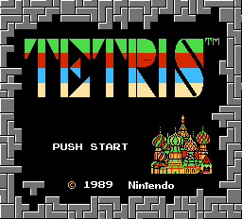
FCE Ultra is back again on this site. When I started this site I added this emulator, which at that time was only for DOS. But I removed it later again because I didn't think it was that good. Since that time however FCE Ultra has gone open source (which means anyone with the right skills can contribute to it) and it has been ported to Windows.
I tried it again after a forum member told me he thought it was good - and he was right: FCE Ultra has been much improved and is a great NES emulator now.
Unfortunately in November 2002 the author of FCE Ultra, Xodnizel, decided to stop working on it as he feels most major goals for it were reached and he has lost the desire to continue to work on it. But don't let this discourage you - although we may not see any new versions, the last version is still one of the best NES emulators available.
Tip: Before you start playing I recommend you reconfigure the controls (Config->Input in the menu) as the default keys didn't work right (for me at least).

